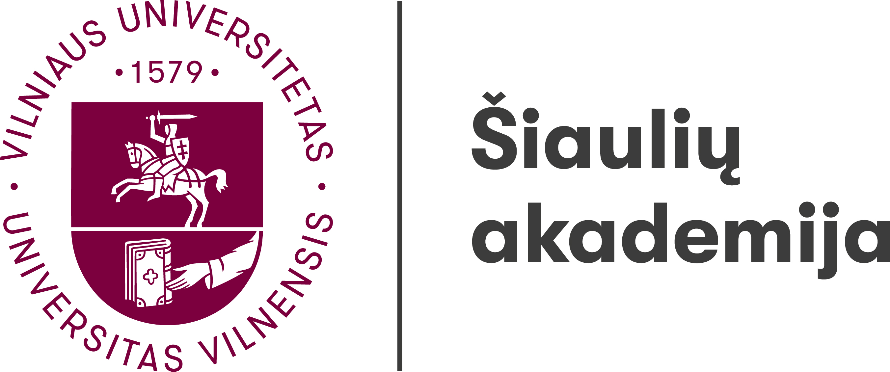

**Institute of Regional Development**

14th International Interdisciplinary Scientific Conference

**THE REGION: HISTORY, CULTURE, LANGUAGE**

15th–16th of May, 2025

Šiauliai

A research group **“Linguistic, Literary and Cultural Research**” organises an international interdisciplinary scientific conference *The Region: History, Culture, Language* on the 15th–16th of May, 2025.

Researchers of different fields are invited to participate and discuss the subject using different perspectives.

Suggested topics:

* Methodologies and methods in regional research;
* Regions in historical research;
* Cultural and communication memory in the region;
* Regional policy and governance;
* Region in ethnology, anthropology and cultural research;
* Regional identity, mentality and self-awareness;
* Ethnographic peculiarities of regions;
* Linguistic understanding of the region, territorial and social dialects, language specifics;
* Regional literature and regional authors, regions and regionality in literature;
* Traditional and contemporary applied and visual art expression in the region;
* Development opportunities for the design sector in the region;
* Regions in the context of informal art education;
* The specifics of musical folklore in the regions;
* The peculiarities of creation, dissemination and perception of professional music in the regions.

Conference languages: Lithuanian, English.

The conference will be held at the Šiauliai Academy (Vytauto st. 84, Šiauliai) and online via the *Microsoft Teams*.

The international interdisciplinary scientific conference “The Region: History, Culture, Language” (15th–16th of May, 2025)

**The conference participantion fee** is 50.00 EUR

**Instition-receiver**: Vilniaus Universitetas

Universiteto g. 3, Vilnius  LT-01513

Account number: LT247044060001101392

AB SEB bankas

Gedimino g. 12, Vilnius  LT-01103

SWIFT code CBVILT2X

**The purpose of the payment** (must be written):

Conference **№ ŠA-2025-05-0001** *(participant name, surname)* fee.

Articles, prepared based on the conference presentations, will be published in the online journal *Acta humanitarica academiae Saulensis* (ISSN 2783-6789).

Registration forms including a summary of the presentation (200–300 words) should be submitted by email: [regina.kvasyte@sa.vu.lt](mailto:regina.kvasyte@sa.vu.lt) till the **17th of April, 2025.**

Available at: <https://www.sa.vu.lt/renginiai/1770-14th-international-interdisciplinary-scientific-conference-the-region-history-culture-language>

Authors will be informed about the inclusion of their papers into the conference programme till the **30th of April, 2025.**

**Conference Scientific Committee:**

*Chairperson* – Dr Regina Kvašytė (Vilnius University Šiauliai Academy, Lithuania)

*Members*:

Dr Juris Ciganovs (Latvian War Museum, Latvia)

Dr Vita Juknevičienė (Vilnius University Šiauliai Academy, Lithuania)

Dr Mihaela Koletnik (Maribor University, Slovenia)

Dr Vladimir Legac (University of Zagreb, Croatia)

Dr Arturs Medveckis (Rīga Technical University Liepāja Academy, Latvia)

Dr Monika Pokorska-Iwaniuk (Adam Mickiewicz University in Poznań, Poland)

Dr Henrihs Soms (Daugavpils University, Latvia)

Dr Anna Stafecka (University of Latvia, Latvia)

Dr Rita Regina Trimonienė (Vilnius University, Lithuania)

Dr Rytis Urniežius (Vilnius University Šiauliai Academy, Lithuania)

Dr Kristīne Vaceka-Ante (Charles University, Czech Republic)

Dr Jolanta Vaskelienė (Vilnius University Šiauliai Academy, Lithuania)



**Institute of Regional Development**

14th International Interdisciplinary Scientific Conference

**THE REGION: HISTORY, CULTURE, LANGUAGE**

15th–16th of May, 2025

Šiauliai

REGISTRATION FORM

To be submitted to **regina.kvasyte@sa.vu.lt** till the **17th of April, 2025.**

Name, surname

Organisation

Position

Academic title and degree

Telephone

E-mail

Address

Presentation topic

Summary of the presentation (200–300 words)

Planning to participate: *online or face to face*

Notes: